ICE Teacher Methodology Course
The Teacher methodology course has been created for experienced English Language Teachers who want to refresh and update their language teaching skills and provides participants with a range of practical activities used in the modern communicative language classroom and the theories that underpin them.

It is delivered by highly qualified and experienced teacher trainers who undertake regular professional development, so you can be sure that they possess up-to-date skills and are passing on the latest research-based theories and activities There is also the opportunity to carry out mini observations of our teachers in classroom action.

Course Details at a Glance

Minimum  Level | Maximum Group Size |  | Course  Duration
B2+ | 12 |  | 1 or 2  weeks
Learning Objectives |  | Assessment
By the end of the course participants will have:  - Refreshed & developed their pedagogical knowledge & how this can be applied to the classroom  - Refreshed & further developed classroom techniques for the communicative classroom.  - Shared ideas & experiences with fellow English Teaching Professionals  - Acquired methods to reduce the effects of a mixed-ability class  - Collected a portfolio of teaching resources  - Increased awareness of how technology can be used in the classroom  - Created a network of teaching contacts for continuing support |  | End-of-week review session to test and consolidate the material covered each week.
 |  | Fees
£250
per week

Sample 2 Week Timetable

Week 1
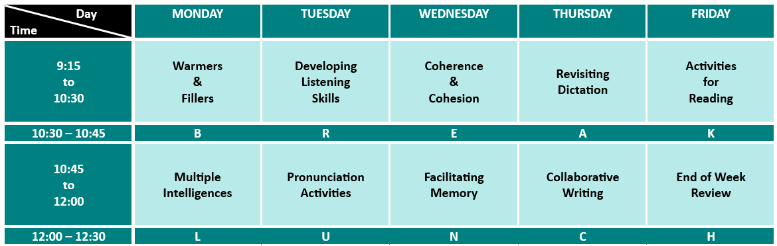

Week 2
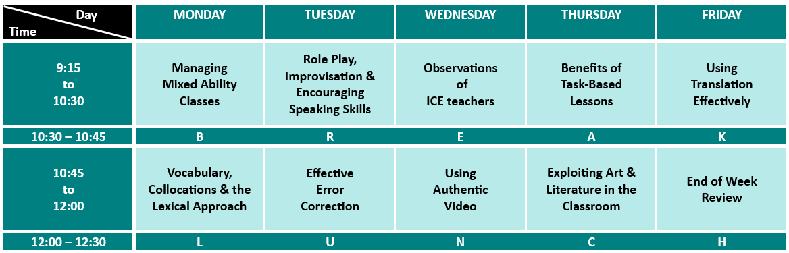

Each session is 75 minutes in length and there are a total of 12.5 input hours per week.

Whether you decide on a one or two-week course, we can create a bespoke timetable for you. Below are a range of sessions, with a brief synopsis of each, for you to choose from:

Multiple Intelligences (no practical activities)
Teachers will look at how different students can have different intelligences and how they can tailor lessons to meet everyone’s needs.

EFL Approaches Overview (no practical activities)
In this session, participants will take a look at a range of different methodologies and approaches developed over the previous century or so that purport to benefit language learning.

Role Play, Improvisation & Encouraging Speaking Skills
Teachers will look at the features of spoken discourse and practice a range of activities that teachers can use in their own class to enable students to improve their language abilities. This will be followed by looking at the key ingredients to a successful role play and trying out a number of activities.

Revisiting Dictation
Teachers will look at the benefits of using dictation in the classroom and look at a range of activities to make dictation more enjoyable and interactive than the traditional model.

Developing Listening Skills
In this session teachers will look at the problems with the traditional listening lesson and activities that they can use to remedy these problems.

Warmers & Fillers
Teachers will look at the importance of warmers and fillers in the classroom and then practise a variety of activities that can be used to start lessons in a positive manner.

Pronunciation Activities
Teachers will look at the importance of teaching pronunciation & practise a number of creative activities that can be used in the classroom.

Using Authentic Video
Teachers will look at the benefits of using movies in the classroom and how to eliminate the potential problems associated with it. We will also practise a number of activities that can be adapted from almost any video clip.

Effective Error Correction
In this session teachers will discuss the importance of error correction in the second language classroom and when it should take place. They will also look at a wide range of techniques that can be used when correcting students’ output as well as handling feedback.

Vocabulary, Collocation & The Lexical Approach
In this session teachers will look at the importance of collocations, why more emphasis should be placed on lexis in the second-language classroom and how this can be achieved.

Activities for Reading
In this session teachers will look at the many sub-skills that make up the skill of reading and activities that can be used to help students improve them.

Collaborative Writing
The teachers will look at a variety of collaborative writing exercises that can help to develop students’ writing abilities whilst also making writing more enjoyable.

Facilitating Memory
This session focuses on factors that affect retention of new material, before looking at techniques and activities that can be utilised by teachers to improve their learners’ retention of material covered in the classroom.

Benefits of Task Based Lessons
In this session participants will have a chance to experience a Task-based lesson as a student would, and then analyse the features of this approach and how it can be of use in the English language classroom.

Managing Mixed Ability Classes
Participants will firstly look at what constitutes a mixed ability class and when it can be a minor or major influence on student achievement. Participants will then look at a range of techniques for both individual activities and classroom management that can be employed to minimize the effect of mixed ability.

Coherence and Cohesion
During this session, teachers will look at an area of language teaching that regularly gets overlooked by course material and how coherence and cohesion are achieved. Teachers will then have an opportunity to try out some activities that can be utilised in the classroom.

Teaching Grammar
Participants will look at the main features of teaching grammar and how these can be achieved by carrying out a number of tasks that can be used with students in the language learning classroom.

Teaching Vocabulary
Participants will look at the main features of teaching vocabulary and trying out a number of tasks that can be used with students to introduce vocabulary in the language learning classroom.

Adapting Coursebook Material
During this session, teachers will utilise the knowledge that they have acquired throughout the course to adapt coursebook material to make it more effective in the presentation, production and retention of the language.

Mini-observations & Feedback
Participants will have the opportunity to observe English language learning classes in action.
After the observations, all participants will be able to discuss their findings with each other and any improvements they feel they can make to their own teaching.

Keeping up with Phrasal Verbs
During this session teachers will look at the importance of phrasal verbs and the 3 main ways that they can be introduced to students. Teachers will then look at a number of activities that can be utilised in the classroom to practice them effectively.

Idioms and Slang
In this session, participants will look at when idiomatic language and slang is appropriate to introduce to students as well as then looking at a number of classroom activities that can be used to practice them.

If there is a session that you’d like that is not on the list, please let us know and our teacher trainers will be more than happy to create it.

Information pack
A supplementary information pack that either reiterates or expands on points from the sessions, or adds further practical activities that can be used in the classroom.

